The Anatomy of Self-Curation
Bernadette Wegenstein

We tend to think of human anatomy as a fact. The human body exists in a form, and its anatomy is a view of that form from the inside, “under the skin,” as it were. But thinking of it in this way requires that we actively forget the intervention of history, technologies, and the power relations that inhere in all the various ways humans have employed to create it. We forget, in particular, that every view inside the body is a construction dependent on the available media of the time, which carry with them innumerable ideological presuppositions. In what follows, I will briefly touch on some historical key points before considering how such a media-theoretical analysis can help us understand the phenomenon of “get ready with me” videos that have become a powerful trend on social media.
From the moment anatomy began to take root as a science and medical practice in early modern Europe, it was imbued with implicit power relations. The influential Swiss theologian and priest Johann Kaspar Lavater (1741–1801) was a major “relationship guru” of his time, who sought a basis for his teachings in an early form of anatomy, namely physiognomy. Lavater believed that morality and outer appearance were deeply connected, writing that “Beauty and ugliness have a strict connection with the moral constitution of Man.” Among his many illustrations is one titled “The Ugliest Ugliness,” whose caption reads, “The unnaturally prominent forehead; the wild eyebrows; the angular and blunt nose; the lacking upper lip; the preponderant lower lip, which almost reaches the end of the rather short nose; the small chin becoming a goiter; [all these characteristics] determine ugliness and stupidity. The eye is goodish.”
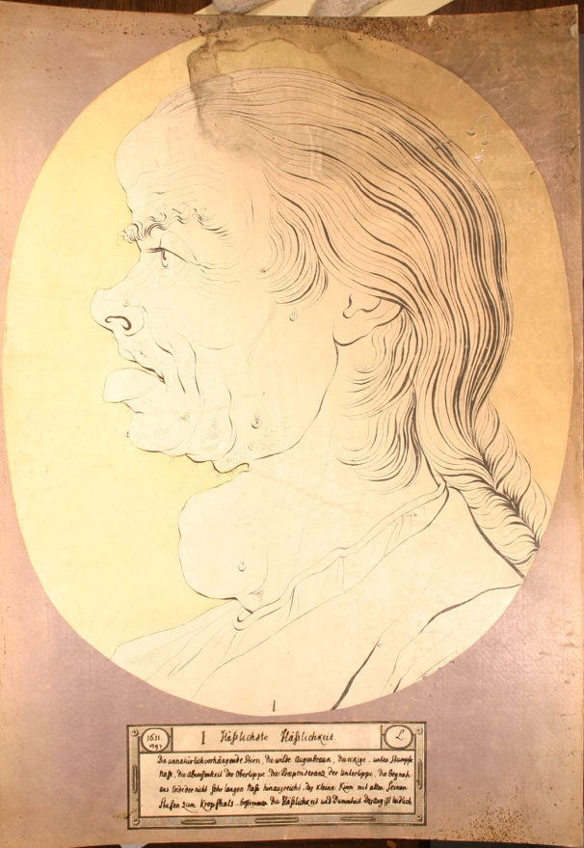
Image 1.

A century later, in his wildly successful book Criminal Man (1876), the physiognomic anthropologist Cesare Lombroso presented evidence that the physical characteristics of primitive man resurface in the born criminal (delinquente nato), whose “evil inclinations” could be read from anatomical traits such as a unibrow and hanging lips. Such theories were formative for the burgeoning antisemitism of the time.
Indeed, the face and the body have never ceased to function as screens for social prejudices. Today, the field of attractiveness studies is undergoing a revival of what is known as Darwinian aesthetics, bolstered by the possibilities of facial recognition software—technologies that Lavater and Lombroso could only have dreamed about. Never have we encountered so many images of beautiful or beautified people, supposedly reflecting a perfect inner life. At its core, makeover culture demands change: change yourself.
A study published in the German weekly Der Spiegel shows that people in the Western world spend, on average, four hours daily on their appearance (makeup, hair, and working out for aesthetic rather than health-related reasons), based on research conducted across 93 countries with 93,000 participants. Women were shown to spend, on average, 24 minutes more per day than men. The wellness and beauty industries are thriving globally and are now comparable in scale to the oil, gas, and automobile industries.
The “getting ready” video trend on TikTok is a new form of aesthetic labor performed by young and vulnerable teenagers across the globe. A young girl named Sofia speaks with the journalist about her habits as a “get ready” influencer. Sofia, a fourteen-year-old from the outskirts of Munich, applies a full face of makeup every morning at 5:30 a.m. Once her “get-ready-with-me” video is posted, it receives 1.6 million views.
In this genre young women like Sofia talk us through their meticulous routines while concealing the software they use (often through jump cuts), presenting the transformation as the result of hard work alone. In one video, for instance, an influencer reveals the order in which she proceeds with her modification through the intense and long-winded application of makeup. Along the way, she shares fragments of her inner life while she “undergoes” the transformation, simultaneously positioning herself as a kind of life coach to her audience:
I usually start with my hair, which is a bit crazy. I am currently covering up my monster pimple. Has anyone been as unmotivated as I have lately? I cannot get myself out of bed.
As she begins applying products, she also recommends them in a familiar influencer register:
Get this product immediately because this is how it makes your skin look. My go to blush for life.
The final look centers on the lips, a theme I will return to at the very end of this article:
The key to your lips is to literally put on a lip mask like that.
In another video, we are getting ready with a famous star, Ariana Grande. She speaks little but offers a glimpse into the process through a “reality-style” confession: she is doing her own makeup, with the help of two professionals, whom she later introduces as her makeup team, smiling and saying “hi” into the camera. Prior to this, we see a “distorted frame” meant to resemble an “old 16mm video,” overlaid with the words [redacted Ari Leak], as TikTok prompts viewers to “identify” AI-generated content. During this moment, the performer says:
We are getting ready for the xxxx [redacted] video Day One.
To interrupt the flow of getting ready, we are offered brief, seemingly casual moments of intimacy. Ariana Grande takes a sip from an oversized cup, showing her hand tattoos. When the makeover begins in earnest, she confesses early on that she is dissatisfied with her skin. Yet she never specifies what exactly troubles her, as the sentence is abruptly interrupted by a cut:
The skin is… CUT
We then continue watching the performer work on her own face, applying products from makeup to lashes, while music punctuates her gestures with dramatic effects. Once again, the process culminates in a focus on the lips:
I know this is insane but I am going to mix three lip glosses.
The final image centers on her lips, now gleaming on the screen, accompanied by the sound of a bell—suggesting a prize won at a jukebox—as she puckers them to blow a kiss. Notably, her lips are shaped in exactly the same way they were two minutes earlier, at the beginning of the video, when she was already wearing lip gloss. But what’s more, the previous influencer’s final image and Ariana Grande’s, are almost identical: the direction in which the face is tilted, the way they look into camera, and of course the way emphasize the lips.
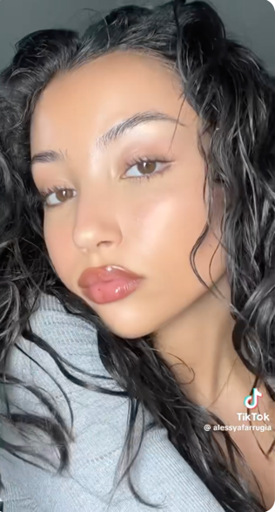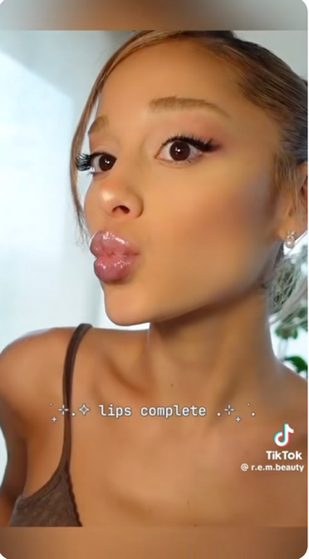
Image 2.
The racial bias embedded in face-tuning software used by TikTok or Instagram is a well-known problem, and I will mention only one illustrative “anatomy trick.” An MIT student named Rona Wang applied for a job and used the face-tuning software Playground.ai. The 24-year-old asked the AI for help to make her look more presentable in a photo she was required to upload. The result was a whitewashed version of herself. Rona, who is Asian, was rendered as a white woman with blue eyes, as the AI appeared to assume she would have a better chance of being hired with this look.
Face-tuning software is more prevalent and mainstream than ever. On the subway in Vienna, Austria, for instance, we encounter advertisements for an app called “Facetune” that promises to make users look as though they have had eight hours of sleep. Yet something more is at work in Facetune, as becomes evident in the group of facetuned testimonials shown below, which I found on the company’s website (see image below).
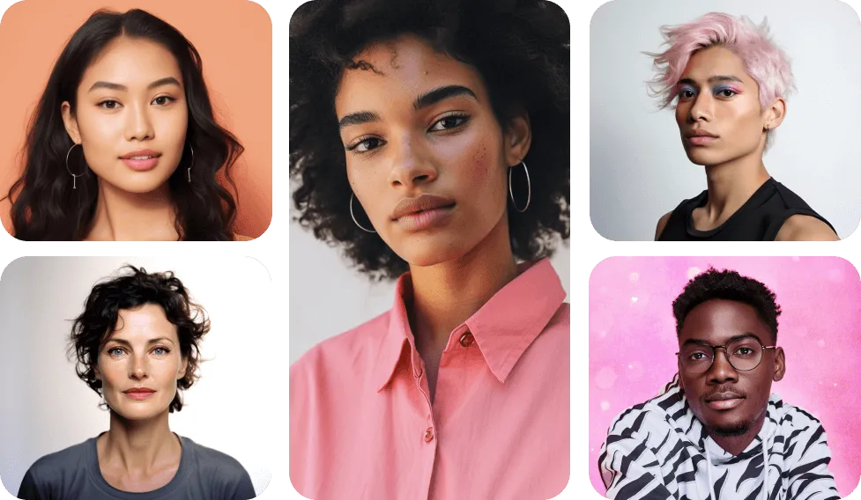
Image 3.
But where does this “smooth homogenic ethnic” look come from? What kind of anatomy is hidden beneath it? Nora Ruck and my research in reality television makeover shows suggests that beautiful faces are, in fact, averaged faces. We can see this logic reproduced in the AI application “This person does not exist,” where each click generates faces that are creations ex machina. TikTok itself uses AI tools that allow users to create avatars of themselves or to modify their appearance. With approximately 100 million new videos uploaded every day, the question of whether these videos are even based on real people becomes increasingly difficult to answer. Some estimates suggest that up to 50 percent of today’s TikTok content is AI-generated. The selfie is not the only genre reflecting us back to ourselves, but since the COVID-19 pandemic of 2021, we have become accustomed to seeing ourselves on screens daily through video chats. We no longer catch occasional glimpses of ourselves in the bathroom mirror but instead encounter our images continuously through the video interfaces of our media platforms.
According to philosopher Heather Widdows, today’s global beauty ideal represents a composite, medial average of multiple ethnic features: voluminous lips, thick hair, full beards, high cheekbones, almond-shaped eyes with double eyelids, long lashes, and large breasts for women or pronounced chest muscles for men. Crucially, no single ethnic group naturally possesses all of these features simultaneously, as the beauty ideal these images promote does not actually exist. As with the images imagined by Lavater, Lombroso, and the eugenicists who followed them, today’s beauty ideals carry largely unexamined assumptions about the value of certain kinds of people. At the same time, they place impossible burdens on young individuals who strive to embody them, often causing serious harm in the process. To understand these mechanisms, we must continually remind ourselves that what appears natural is—and has always been—constructed upon a self-erasing scaffolding of media technology, frequently supported by the exploited aesthetic labor of the very young.
What about the question of the prominent lips visible in nearly all “get-ready-with-me” videos? These so-called “Russian lips”—named because the technique and look are said to have originated in Russia—echo the painted lips of Russian Matryoshka dolls, which relied on hand-drawn techniques applied to wood. Yet the first time this lip style went viral appears to have been with silent film star Clara Bow, “the first it-girl,” featured in Wine in 1924. The story behind Bow’s heart-shaped lips is that her makeup would melt under the intense heat of early film lighting. In response, makeup artist Max Factor devised a technique in which he grounded her lips in white and then dipped his fingertips in black pomade, pressing them onto her lips to create the imprint of a mouth. The result was the legendary “bee stung” look—a mouth that appeared as though it had just been stung. What these examples reveal is that, whether analogue or digital, makeover culture has always relied on technological effects produced through trompe-l’œil.
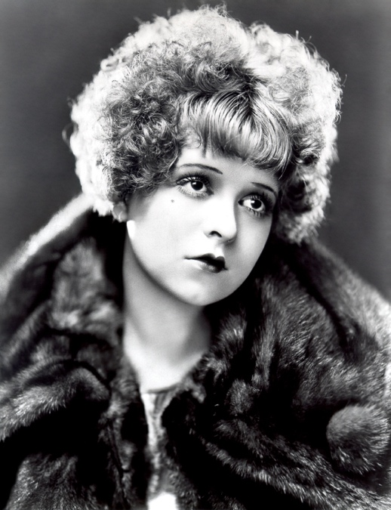
Image 4.

Bibliography
Calfas, Jennifer. “Student Uses Playground AI for Professional Headshot—and It Turned Her into a White Woman, She Says.” Business Insider, August 2023. https://www.businessinsider.com/student-uses-playrgound-ai-for-professional-headshot-turned-white-2023-8.
Der Spiegel. No. 45 (October 10, 2025).
Lombroso, Cesare. Criminal Man. Translated by Mary Gibson and Nicole Hahn Rafter. Durham, NC: Duke University Press, 2006. Originally published as L’uomo delinquente (Turin, 1876).
Städeli, Markus. “TikTok wird zur Schrotthalde von KI.” Neue Zürcher Zeitung, November 11, 2025.
This Person Does Not Exist. Website. Accessed [insert access date]. https://thispersondoesnotexist.com/.
Wegenstein, Bernadette. The Cosmetic Gaze: Body Modification and the Construction of Beauty. Cambridge, MA: MIT Press, 2012.
Wegenstein, Bernadette, and Nora Ruck. “On Physiognomy, Reality Television, and the Cosmetic Gaze.” Body & Society 17, no. 4 (December 2011): 1–26.
Widdows, Heather. Perfect Me: Beauty as an Ethical Ideal. Princeton, NJ: Princeton University Press, 2018.

See Bernadette Wegenstein, The Cosmetic Gaze: Body Modification and the Construction of Beauty (Cambridge, MA: MIT Press, 2012), for a discussion of Johann Kaspar Lavater’s Physiognomische Fragmente (1775–1778), later translated as Essays on Physiognomy (London: John Murray, 1789).
Cesare Lombroso, Criminal Man, trans. Mary Gibson and Nicole Hahn Rafter (Durham, NC: Duke University Press, 2006), originally published as L’uomo delinquente (Turin, 1876).
Wegenstein, The Cosmetic Gaze, 2; This is the imperative I have called the cosmetic gaze, “through which the act of looking at our bodies and those of others is informed by the techniques, expectations, and strategies of bodily modification.”
Carola Padtberg, “Spritzen, Schminken, Stress,” Der Spiegel, no. 45 (October 10, 2025).
McKinsey consultancy estimates the beauty industry alone (excluding wellness) at $580 billion and projects a growth rate of six percent by 2027.
Carola Padtberg, “Spritzen, Schminken, Stress,” Der Spiegel, no. 45 (October 10, 2025).
Jennifer Calfas, “Student Uses Playground AI for Professional Headshot — and It Turned Her Into a White Woman, She Says,” Business Insider, August 2023, https://www.businessinsider.com/student-uses-playrgound-ai-for-professional-headshot-turned-white-2023-8.
Bernadette Wegenstein and Nora Ruck, “On Physiognomy, Reality Television, and the Cosmetic Gaze,” Body & Society 17, no. 4 (December 2011): 1–26.
This Person Does Not Exist, website, accessed [insert access date], https://thispersondoesnotexist.com/.
Markus Städeli, “TikTok wird zur Schrotthalde von KI,” Neue Zürcher Zeitung, November 11, 2025.
Heather Widdows, Perfect Me: Beauty as an Ethical Ideal (Princeton, NJ: Princeton University Press, 2018).
Der Spiegel, no. 45 (2025): 12.

