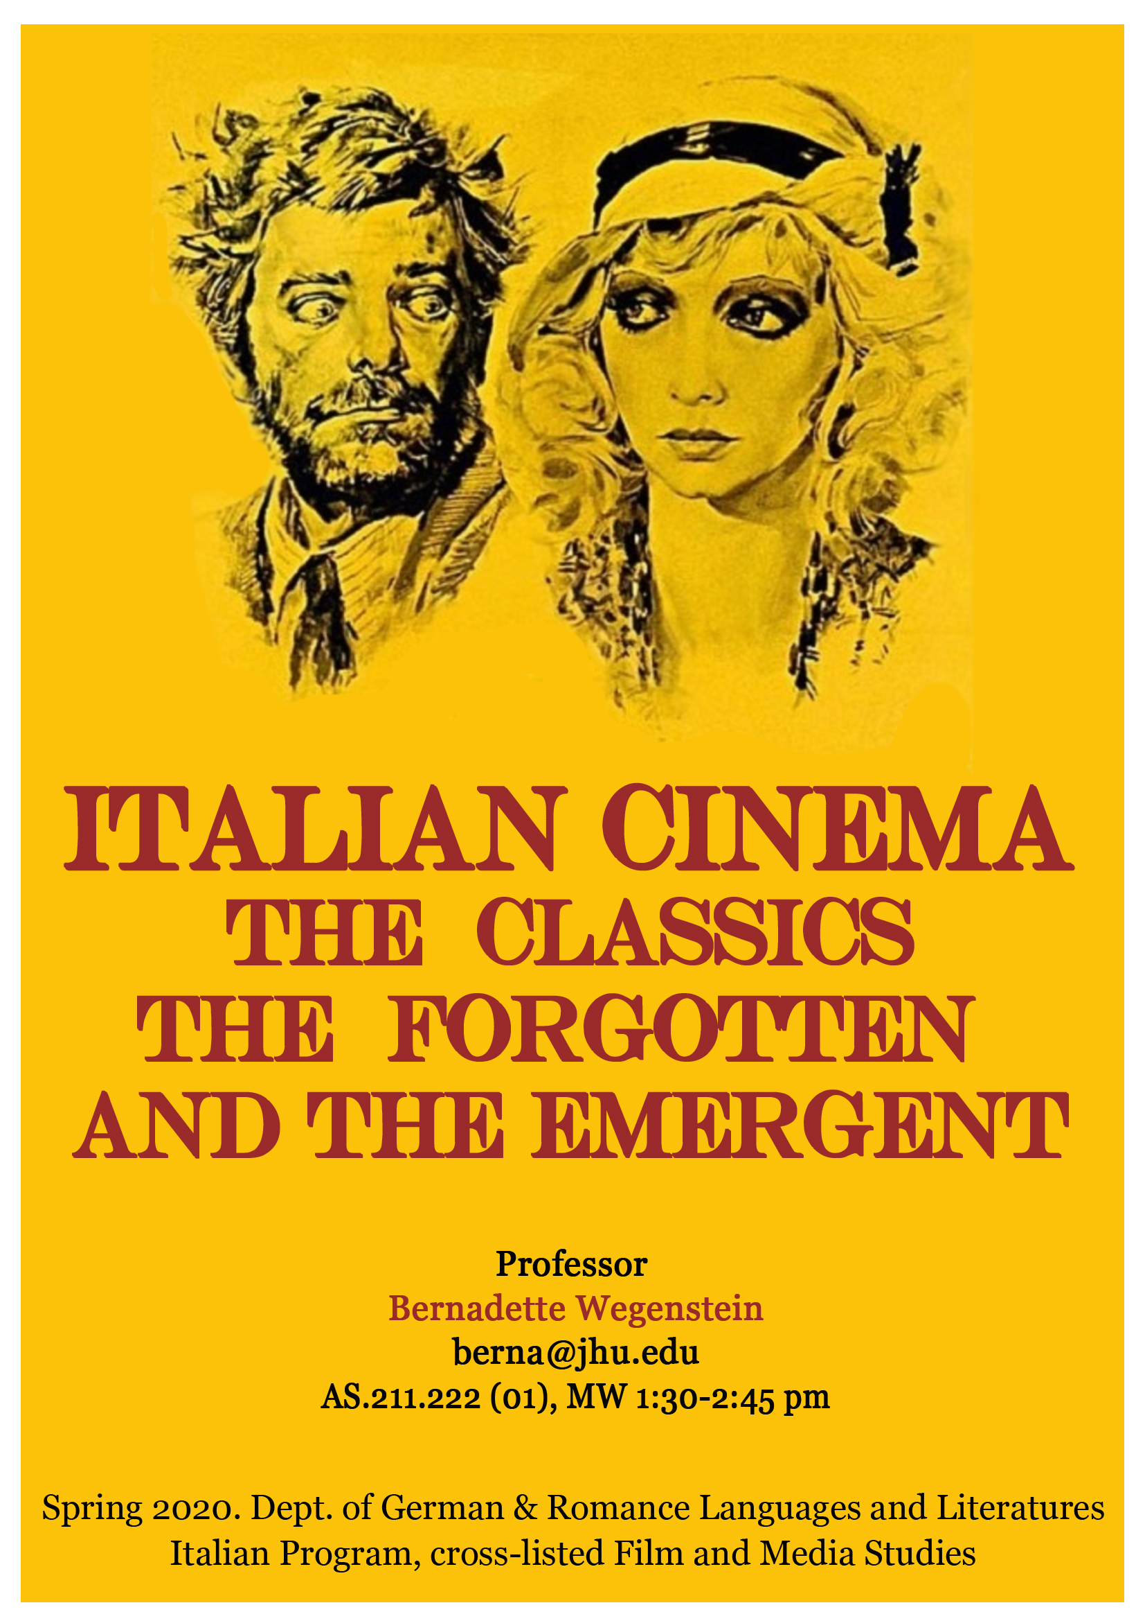
COURSE DESCRIPTION:

This course traces the history of Italian cinema from the silent era to the new millennium, highlighting its main trends and genres, and reflecting on the major transformations modern and contemporary Italian society experienced over the twentieth and twentieth-first centuries. We shall examine iconic films such as Vittorio De Sica’s Bicycle Thieves, Federico Fellini’s La Dolce Vita, Michelangelo Antonioni’s L’Avventura, and Pier Paolo Pasolini’s Mamma Roma, that received international recognition and influenced other national, cinematic productions. We shall also look at the work of less famous, or independent filmmakers who received less critical attention. While this class takes an historical approach, it also includes a theoretical component and introduces students to the specificity of the cinematic language, examining films in relation to the mise-en-scène, frame composition, camera movements, editing, and sound. This class is taught in English.

COURSE OBJECTIVES

- Develop or improve a critical approach to the film medium while acquiring or solidifying the cinematic vocabulary necessary to the analysis of the mise-en-scène.
- Learn how to recognize and deconstruct stereotypical representation of class, ethnicity and gender in film.
- Gain knowledge of the history of Italian cinema, while developing a more complex understanding of Italian culture.
COURSE REQUIREMENTS

Students are expected to arrive to class having watched the films and taken screening notes in order to participate to the discussion. Students will be engaged in practical film analysis and asked to respond to questions related to material discussed in class. There will be one written exam in which students will respond to questions related to the films and readings included in the syllabus. Students will be also required to submit a 1 page paper proposal and write a 7-10 page final paper. Guidelines and requirements for the paper proposal and final paper will be given before Thanksgiving break. Each student is also required to give at least one, 15-minute oral class presentation on a topic to be approved by the instructor.

While the course is taught in English, special sessions in Italian for students from the Italian major or minor will be announced during the semester. All the films are in Italian with English subtitles.

Your final grade will be evaluated in the following manner:

- Class attendance: 20%
- Participation in discussions, writing activities and assignments: 25%
- Oral presentation: 10%
- Midterm Exam: 20%
- Final paper: 25%

ATTENDANCE POLICY

Lateness in delivering the assignments and more than two unexcused absences will lower your grade and may, at the discretion of the instructor, result in a failing grade. Students are excepted to notify the instructor when they are unable to attend class and discuss how to make up missed class time or assignments.

ACADEMIC ETHICS
The strength of the university depends on academic integrity. In this course, you must be honest and truthful. Ethical violations include cheating on exams, plagiarism, reuse of assignments, improper use of the Internet and electronic devices (including Blackboard activities), unauthorized collaboration, alteration of graded assignments, forgery and falsification, lying and unfair competition. Report any violations you witness to the instructor. We would like to draw your attention to the University's Undergraduate Academic Ethics Board Statement on Ethics, which reads:
"Make certain that you know exactly what is and what is not permitted in the class. If you are unsure about the rules concerning an assignment, do not assume anything; ask your instructor for a clarification. This is especially important for group projects, where students are often allowed to work together but must submit individual reports or papers. Unfortunately, many individuals who have records of academic misconduct simply did not understand the rules of an assignment. Don't risk your academic reputation by keeping quiet." http://www.jhu.edu/ethics/statement.html
See the guide on Academic Ethics for Undergraduates and the Ethics Board web site (http://ethics.jhu.edu) for more information.
DISABILITY
Any student with a disability who may need accommodations in this class must obtain an accommodation letter from Student Disability Services, 385 Garland, (410) 516-4720, studentdisabilityservices@jhu.edu

COURSE OUTLINE
Week 1: Building a Cinematic Language/ Italian Silent Cinema
January 27: Introduction to the class. Screening with a Questioning Mind.
Short films from the collection “Gran Tour Italiano”
January 29: Cabiria by Giovanni Pastrone, 1913
Scenes from Maciste all’inferno (Maciste in Hell) by Guido Brignone, 1925
: Giorgio Bertellini, “Silent Italian Cinema. An International Story” in P. Bondanella, ed. The book of Italian Cinema. pp 9-16; Jacqueline Reich, “Italian Silent Film. Comics, Serial, Historical Epics and Strongmen” in P. Bondanella, ed. The book of Italian Cinema. pp 31-37

Week 2: Pioneering Women Filmmakers and Cinema under Fascism

February 3:
Scenes from A piccerella (She’s a Little One) by Elvira Notari, 1926
Scenes from A santa notte (The Holy Night) by Elvira Notari, 1922
Scenes from Fantasia e surdate (A Soldier’s Dream) by Elvira Notari, 1927
: G. Bruno, “City Views. The Voyage of City Images,” in D. Clark, The Cinematic City.
February 5:
Scenes from Scipione l’africano. (Scipio Africanus. The Defeat of Hannibal) by Carmine Gallone, 1937
Scenes from Gli Uomini che Mascalzoni. (Men, What Rascals!) by Mario Camerini, 1932
: David Forgacs, “Fascism and Italian Cinema” in Peter Bondanella, ed., The Italian Cinema Book. Pp. 41-49

Week 3: Neorealist Cinema

February 10: Ladri di biciclette (Bicycle Thieves) by Vittorio De Sica, 1945
Scenes from Sciuscià by Vittorio De Sica, 1946
: Cesare Zavattini, “Some Ideas on Cinema.”
February 12: Roma città aperta (Rome Open City) by Roberto Rossellini, 1946
Scenes from Paisà, (Paisan) by Roberto Rossellini, 1948
: Bert Cardullo, “What is Neorealism?” in André Bazin and Italian Neorealism

Week 4: Neorealism, Rosy Neorealism and the End of Neorealism

February 17: Riso amaro (Bitter Rice) by Giuseppe De Santis,1949
Scenes from Pane amore e fantasia (Bread, Love and Dreams) by Luigi Comencini, 1953
In class screening of short movies from the collection Il mondo perduto (The Lost World) by Vittorio De Seta, 1954-1959

: Millicent Marcus, “De Santis’s Bitter Rice,” in Italian Film in the Light of Neorealism, 76-95
February 19: Le notti di Cabiria (Nights of Cabiria) by Federico Fellini, 1957
: André Bazin, “Cabiria: The Voyage to the End of Neorealism”
Frank Burke, “The Nights of Cabiria,” in Federico Fellini: Variety Lights to La Dolce Vita, 69-83

Week 5: Beyond Neorealism

February 24: Mamma Roma by Pier Paolo Pasolini, 1961
In class screening: La ricotta by Pier Paolo Pasolini (Curd Cheese), 1963
: John David Rhodes, “Mamma Roma and Pasolini’s Oedipal (Housing Complex)”
February 26: L’avventura by Michelangelo Antonioni, 1960
: Michelangelo Antonioni “The Adventure of L’avventura” in The Architecture of Vision, pp. 78-81.
Andrew Sarris, “Notes on the Auteur Theory in 1962” in Film Theory and Criticism ed. by G. Mast and M. Cohen, pp. 528-540

Week 6: The Cinema of Economic Miracle

March 2: La Dolce Vita by Federico Fellini, 1960
: Peter Bondanella, La dolce vita. “The Art Film Spectacular.” In The Films of Federico Fellini,.pp. 65-115
March 4: Io la conoscevo bene (I knew her well) by Antonio Pietrangeli, 1963
: Laura Mulvey, “Visual Pleasure and Narrative Cinema” In Film Theory and Criticism: Introductory Readings. pp. 833-44.

Week 7. Comedy Italian Style and Spaghetti Western

March 9: Divorzio all’italiana (Divorce Italian Style) by Pietro Germi, 1963
R. Fournier Lanzoni, “Italian Comedy in the 1960s” and “Regional Comedies: Pietro Germi’s Style” in Comedy Italian Style. The Golden Age of Italian Film Comedies, pp. 47-67; 105-116.
March 11: C’era una volta il West (One Upon a Time the West) by Sergio Leone, 1968
: Marcia Landy, “History, Genre, and the Italian Western” in Italian Film.

Week 8. Political Comedies from the 70s

March 23: Mimi Metallurgico ferito nell’onore (Mimi’ the Metalworker, Wounded in His Honor) by Lina Wertmuller, 1974
: Ruth Ben-Ghiat, “The Italian Cinema and the Italian Working Class”
March 25: La pelle (The Skin) by Liliana Cavani,1981.
: Ruth Glynn, “Engendering Occupation: The Body as Warzone in Liliana Cavani’s La pelle”

Week 9. Female Gazes: The 80s and the 90s

March 30: L’amore molesto (Nasty Love) by Mario Martone, 1996.
: Aine O’Healy, “Revisiting the Belly of Naples. The Body and the City in the films of Mario Martone.”
April 1: Midterm Exam

Week 10: The Cinema of the New Millennium

April 6: Gomorra by Matteo Garrone, 2006
: Millicent Marcus, “Gomorra by Matteo Garrone, “‘La normalità dello sfacelo’”
April 8: La grande bellezza, (The Great Beauty) by Paolo Sorrentino, 2013
: Vito Zagarrio, “The Great Beauty or Form Is Politics”

Week 11: Italian Eco-cinema
April 13: Bella e perduta (Lost and Beautiful) by Pietro Marcello, 2015
April 15: Le meraviglie, (The Wonders) by Alice Rohrwacher, 2014
Serenella Iovino, “Ecocriticism and a Non-Anthropocentric Humanism. Reflections on Local Natures and Global Responsibilities”
Scenes from Le quattro volte (The Four Times) by Michelangelo Frammartino, 2010

Week 12: Italian Migrant Cinema
April 20: Fuocoammare, (Fire at Sea) by Gianfranco Rosi, 2016
April 22: Zhang, Gaoheng, Documentary films on migrations in Italy: Characteristics and ethics. Journal of Italian Cinema & Media Studies. Jan 2018, Vol. 6 Issue 1, p.3-14.

Week 12: Mocking Mafia & Pope

April 27: Ammore e Malavita (Love and Bullets) by Manetti Brothers, 2017; Il giovane Papa (The Young Pope) by Paolo Sorrentinto (2019)
April 27 Anna Manzato, Antonella Mascio: The Young Pope. An Italian ‘celevision’ case study. Journal of Italian Cinema and Media Studies. June 1, 2019, Vol. 7 Issue 3, p. 411-424.
April 29: Final Discussion and presentation of final projects.

May 4: Submission of final papers

Note: The syllabus is subject to change. Please make sure to check Blackboard regularly for the most recent version of the syllabus and for announcements on its variations, as well as for the assignments for each class.

The films indicated in the syllabus on a specific date are the films for discussion that students are required to watch at home or in the library. Scenes from additional films from the same period will be screened in class for comparison. With a few exceptions, all the films included in the syllabus are available in the library.

