Media in the Age of Apophenia: Why the Study of Media Art
and Theory is more Important Today than Ever
Bernadette Wegenstein, media theorist and filmmaker
The Johns Hopkins University

If there is something we cannot and shouldn’t escape, it’s our relationship to our own bodies, for it is more real than any other relationship we might come across in our lives, simply because anything we experience will always come back as as sign, code, stimulus, or feeling to our own bodies. Throughout our lives, our bodies adopt a myriad of instantiations of in-betweenness to express our shifting identities, from young to old, from man to woman, from invisible to visible, and so on. While this might sound like an advertisement for a new hair-coloring shampoo for one’s greying hair, it really isn’t just a celebration of the transformability of our shape-shifting-bodies, although it is also that. More importantly, I celebrate it as a signpost for the body as the first “other” we as humans have had to come to terms with—or to say it in German, to “aus-einander-setzen,” which means to “cope with” while also to “place outside of ourselves.”

And for most of us who aren’t “normalized” and whose bodies will therefore remain “marked” as “outsiders,” this is a life-long learning experience.

Ours is an age of “apophenia,” where identity is visible, accessible, quantified, and datafied (Hitho Steyerl, 13). It is an age when living the self on the internet has become an increasingly dysphoric era of bodily self-expression—from Jennicam making us a take part in deadly long hours in her bathroom routine, to being frantically deluded into a “trick mirror” (Jia Tolentino, 7)—from which bodily action is no longer required from us other than as consumption, active or passive, by pressing a few buttons or engaging with a cyber-avatar who listens to us on our own in-built jennicams. In this day and age, media are no longer the ominous and celebrated “extensions” of our bodies, but are rather an extension for those who want to track us down, and turn our data-flesh into ruthless information for selling a form of “automated aesthetics” (Lev Manovich, 1) that benefits in some shape or form someone’s capital gain—mostly if not exclusively Jeff Bezos’s.

But where is the “advantage” in all this in an age of cyber-capitalism? And what does media art and theory bring to the table now that is worth pursuing?

Being embodied and “other” to ourselves can be an advantage when it comes to turning this experience into media language, or any form of mediatization, because as human beings we share the above-described experience of having been “other” and put “outside” of “ourselves” (aus-einander-gesetzt). Hence, the more we intensify our engagement, from 117.2/96.5 inch screens to the latest Quibi content made for portable devices, what comes back on all these devices is a reflection of us and our othered selves. This is the nature of the gaze. It is circular (Kaja Silverman).

Take the female body: since long before the modern age female subjectivity has been conceptualized as difference, then othering, then resistance to “all adequate definition” (Irigaray). If there is something positive about this or any other struggle of a body that is up against the cruelty of the conflict between brown vs white, female vs male, gay vs straight etc. bodies, with #metoo we have now entered an age of outing, making visible, and no longer camouflaging that very difference and that power struggle entirely. Rather, we have entered into an era where “difference” is a hot topic and a highly sellable commodity. This is not yet the age of healing the scars of rape, enslavement, or any other form of even more benign subjugation, to be sure, and it could be said that there is more harm done than not by exposing the trauma of people’s vulnerabilities; this is an age, however, that puts the “exploding kitten” card openly on the table with no “diffuse card” to defend it. To move one metaphor further from a popular card game to a popular body game: we have adopted a beautifully advanced “mental yoga pose,” if not one of the final poses before nirvana, to wrap our heads around the meaning and the place of difference in feminist philosophy and more recently in trans, queer, and queer of color studies, where for instance the wonderful work of José Muñoz has identified “queer hybridity” or “terrorist drag” as a political form of disidentification and hence a practice of freedom.

This freedom does not come for free though, as no freedom ever has. It is said that there are three ways to react to terror: fight, flight, and freeze. In this age of digital persecution and cyber-terrorism, the body is undergoing all of these reactions, and the media culture is bringing it all home to us. The “other body” is on the run yet again, evading a “pattern,” creating a new kind of freedom by resisting a form of clear identification, as Irigaray or Muñoz have suggested.
There are many examples from current media art work produced in the U.S. and beyond to bring to the table to show some of this new work of pattern-evasive media art work. The artist Kandis Williams, for instance, grounds her artistic practice by troubling the identity slots into which the broader culture tries to fit her. Williams evades a clear interpretation of shapes, forms, or racial identifications in her composite-paintings. Nothing is clearly in the foreground or background but every shape is a reflection in the reflection. By taking out the color, nothing is a oneness or one place, one identity, one color.

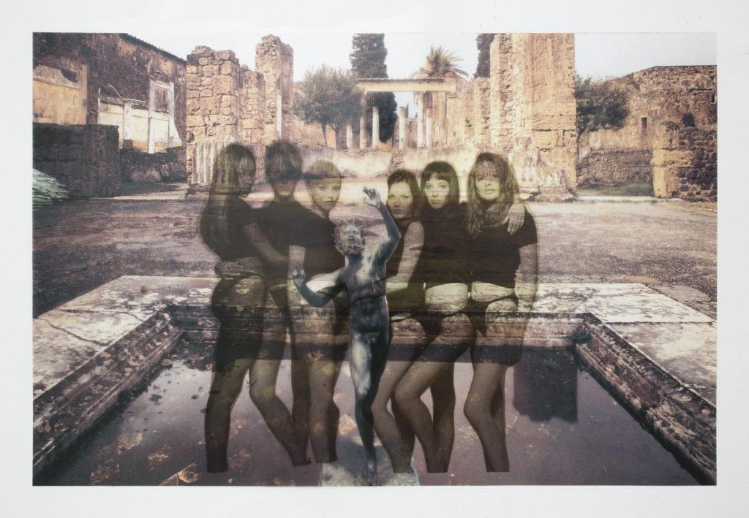
Figure 1.14: Kandis Williams, Shallow pool of Bacchanal Freedom (2018)

The circular nature of the gaze has not changed for any media age, whether it be the invention of the Gutenberg press, the world wide web, or the age of e-trolls and memes. Today’s media culture, precisely because it is a capitalist battlefield, requires us artists, intellectuals, and media producers to reconnect with the screen by way of feeling-seeing, participation, empathy, and point of view. I have written elsewhere that a “feminist filmmaking” practice is one that takes the circularity of the gaze fully into account. We don’t only see from one point, but from all around us, we can see through our bodies, and reveal what’s behind them, just as in Kandis Williams’s Shallow pool of Bacchanal Freedom. The upside to this age of “apophenia,” is hopefully not its “cruel optimism” (Lauren Berlant), but to find othered ourselves and our altered identities in the alternate media we create.

Bibliography:

Berlant Lauren, Cruel Optimism, Durham and London, Duke University Press, 2011

Irigaray, Luce, This Sex Which Is Not One, Ithaka, New York, Cornell University Press, 1985

Apprich Clemens/ Chun, Wendy Hui Kyong/ Cramer, Florian/ Steyerl, Hitho, Pattern Discrimination: In Search of Media, Minnesota and London, Minnesota University Press, 2018

Tolentino, Jia, Trick Mirror: Reflections on Self Delusion, New York, Random House, 2019

Manovich, Lev, Automating Aesthetics: Artificial Intelligence and Image Culture, manovich.net, accessed December 15 2019

Muñoz, Jose Estéban, Disidentifications: Queers of Color and the Performance of Politics, Minnesota and London, Minnesota University Press, 1999

Silverman, Kaja, The Threshold of the Visible World, London and New York, Routledge, 1996

Bernadette Wegenstein, Is there Such a Thing as Feminist Documentary?, in: Viewfinder, London, British Universities Film & Video Council, 2018

According to the rules of the Exploding Kitten card game, once the exploding kitten card is on the table the player loses unless they have a “defuse” card.

